1) INTRODUCTION

1.1 Overview:

A company specializing in offering help and support to organization regarding assistanceto deliver their development program and ambitions.

1.2 Purpose

1) Business Developing

2) Created Logo

3) Improved their business ideas

2) PROBLEM DEFINITION & DESIGN THINKING

A) Empathy Map

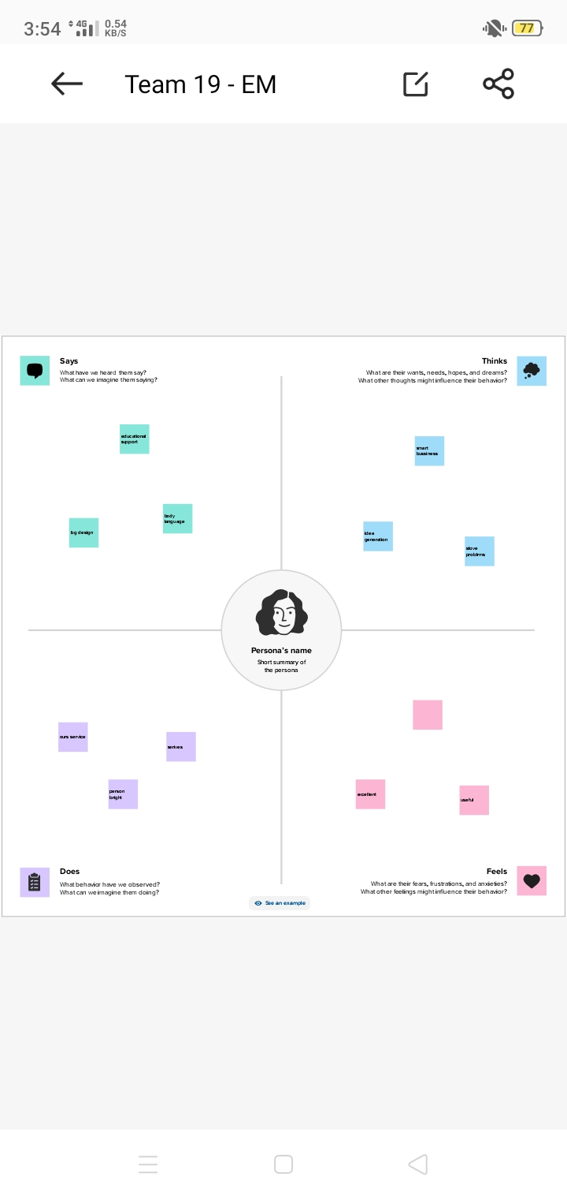

B) Ideation & Brainstorming Map

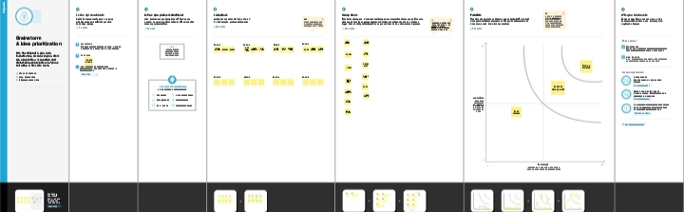

3 Result

A) Profit & Loss A/c

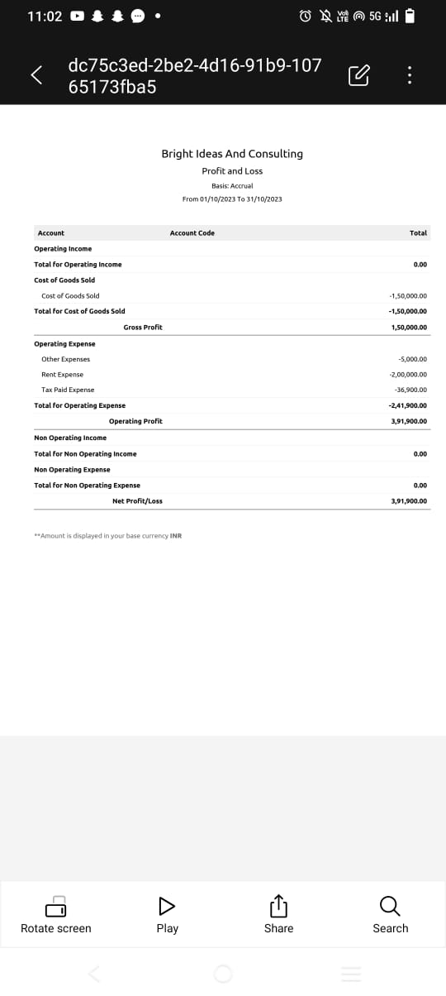

B) Balance Sheet

4) Adv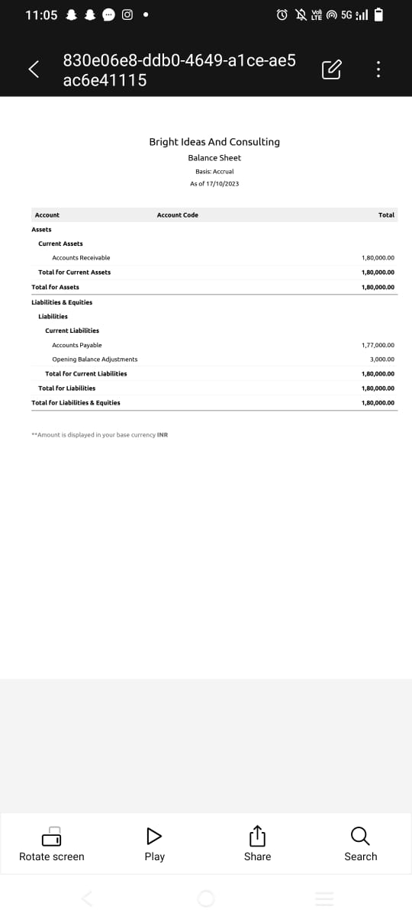

ADVANTAGES

1) Fairly Lucrative

2) Prestigious of Fairly

3) Interesting and diverse case

4) Oppourunties Of Jobs

5) Counsulting firms are in generally meritocracies.

DISADVANTAGES

1) Greater risk

2) Travel, depending on the firm and practice area.

3) Compettion between partners

4) Other personal Demands

4) APPLICATION

1) Communication

2) Financial Analysis

3) Human Resources

4) Marketing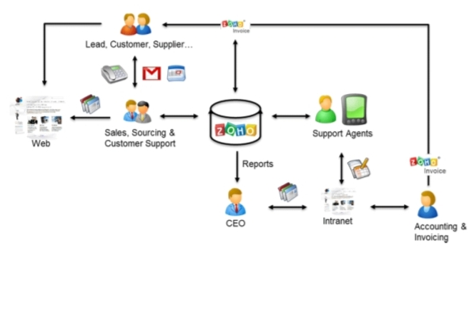

5) CONCALUSION

1) acknowledgement any material

2) Business process development

3) Knowledged to developing growth

4) Resurcesments

6) FUTURE SCOPE

1) Existing a Potential problems

2) Business design

3) Implementable

4) Business Needs

5) Realistic